**Overview**

MYSQL provides lot of built in functions which can be used for transformation to

meet our requirements.

* SINGLE ROW FUNCTION => It operates on a single row at a time. It returns one result per row.
* MULTIPLE ROW FUNCTION => It operates on groups of rows. It returns one result for a group of rows.

**SINGLE ROW FUNCTIONS**

1. **CHARACTER FUNCTIONS**

Allow us to manipulate string values for display. Some of the manipulations are:

1. Concatenating strings,adding text

**mysql> select concat(ename,' is working as ',job) "employee and his job" from**

**emp;**

1. Substring from a string(substr/substring)

It can return specific character or specific length of characters from

the specified position. Can take 2 or 3 arguments.

**mysql> select substr('helloworld',5),substr('helloworld',1,1);**

1. Position of a string(Instr)

It may be required to find the position of a character. (it gives only 1st occurrence). Look at the following example.

**mysql> select instr('helloworld','l') as position**

1. Length of a String

**mysql> SELECT LENGTH('mary had a little lamb');**

1. Left/Right

Both of these functions we specify string, length of the string to be kept, relative to

right or left.

**mysql> select left('hello world',5),right('helloworld',5);**

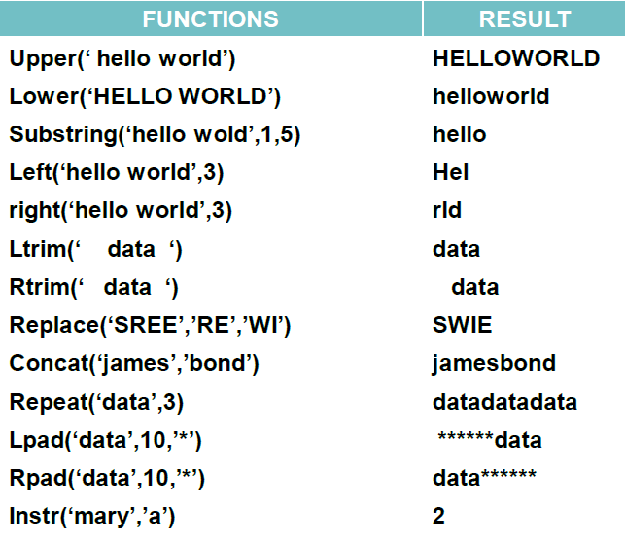

**B) NUMERIC FUNCTIONS**

1. MOD

Remainder can be found using the mod function. I want to find an odd empno, the following query can be written.

***mysql> select empno from emp where mod(empno,2)=1;***

1. SIGN

Returns -1 if negative number, 1 if positive number, 0 if result is zero.

To compare 2 numbers.

***mysql> set @v1=10;***

***mysql> set @v2=20;***

***mysql> set @v3=20;***

***mysql> select sign(@v1-@v2),sign(@v2-@v3),sign(@v3-@v1);***

1. ROUND/TRUNCATE/CEIL/FLOOR

***mysql> select ceil(91.1),floor(91.9),round(100.218,2), truncate(100.218,2);***

+------------+-------------+------------------+---------------------+

| ceil(91.1) | floor(91.9) | round(100.218,2) | truncate(100.218,2) |

+------------+-------------+------------------+---------------------+

| 92 | 91 | 100.22 | 100.21 |

+------------+-------------+------------------+---------------------+

1. ASCII/CHAR/ABS/POWER/SQRT

**mysql> select sqrt(625),power(7,3),ascii('a'),char(65 using ascii);**

+-----------+------------+------------+----------------------+

| sqrt(625) | power(7,3) | ascii('a') | char(65 using ascii) |

+-----------+------------+------------+----------------------+

| 25 | 343 | 97 | A |

+-----------+------------+------------+----------------------+

**C) DATE FUNCTIONS**

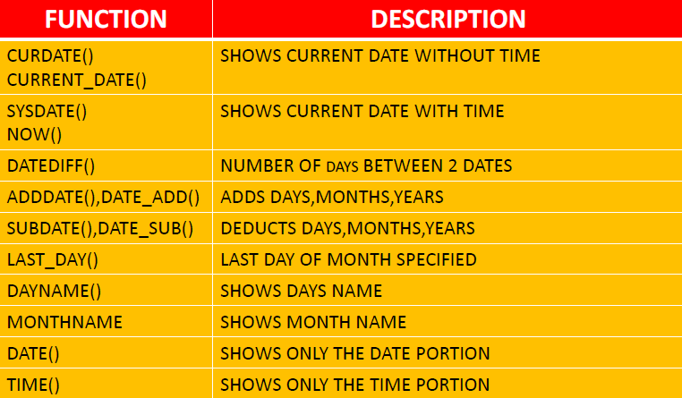

1. CHANGING DATE VALUES

mysql> **s*elect date_add(curdate(),interval '1' day) "add 1 day",***

***date_add(curdate(),interval '1' month) "add 1 month",***

***date_add(curdate(),interval '1' year) "add 1 year";***

+------------+-------------+------------+

| add 1 day | add 1 month | add 1 year |

+------------+-------------+------------+

| 2022-08-13 | 2022-09-12 | 2023-08-12 |

+------------+-------------+------------+

mysql> **select date_sub(curdate(),interval '1' day) "deduct 1 day",**

**date_sub(curdate(),interval '1' month) "deduct 1 month",**

**date_sub(curdate(),interval '1' year) "deduct 1 year";**

+--------------+----------------+---------------+

| deduct 1 day | deduct 1 month | deduct 1 year |

+--------------+----------------+---------------+

| 2022-08-11 | 2022-07-12 | 2021-08-12 |

+--------------+----------------+---------------+

mysql> ***select last_day(curdate());***

1. Difference between dates

mysql> **select timestampdiff(month,'2020-08-12',curdate());**

+---------------------------------------------+

| timestampdiff(month,'2020-08-12',curdate()) |

+---------------------------------------------+

| 24 |

+---------------------------------------------+

mysql> **select timestampdiff(year,'2020-08-12',curdate());**

+--------------------------------------------+

| timestampdiff(year,'2020-08-12',curdate()) |

+--------------------------------------------+

| 2 |

+--------------------------------------------+

mysql> **select timestampdiff(day,'2020-08-12',curdate());**

+-------------------------------------------+

| timestampdiff(day,'2020-08-12',curdate()) |

+-------------------------------------------+

| 730 |

+-------------------------------------------+

mysql> **SELECT DATEDIFF(curdate(),'2020-08-12');**

+----------------------------------+

| DATEDIFF(curdate(),'2020-08-12') |

+----------------------------------+

| 730 |

+----------------------------------+

1. Date_Format

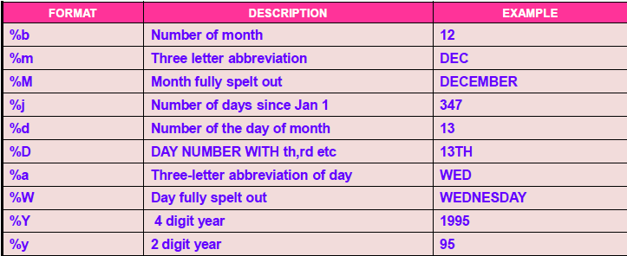

**D) CONTROL FUNCTIONS**

1. **CASE**

There are two versions of using CASE statement:

Version 1:

**CASE value WHEN [compare_value]**

**THEN result [WHEN [compare_value]**

**THEN result ...] [ELSE result] END**

It has been decided to pay bonuses based upon jobs.

For clerk job 1.5 times the salary, analyst 1.75 times the salary, salesman 2.0

times the salary and others only salary as bonus. Let us use CASE to arrive at the

bonus.

mysql> **select ename,job,sal,**

**-> (case when job='clerk' then 1.5*sal**

**-> when job='analyst' then 1.75*sal**

**-> when job='salesman' then 2.0*sal**

**-> else**

**-> sal**

**-> end) "bonus"**

**-> from emp**

**-> order by 2;**

Version 2:

CASE [COL NAME] WHEN [condition] THEN result WHEN [condition] THEN result ...

ELSE result

END

**mysql> select ename,job,sal,**

**(case job**

**when 'clerk' then 1.5*sal**

**when 'analyst' then 1.75*sal**

**when 'salesman' then 2.0*sal**

**else sal**

**end) "bonus" from emp;**

1. **IF(expr1,expr2,expr3)**

IF function accepts three arguments and the result is returned based on if

expr1 is TRUE.

If expr1 is evaluated to TRUE, the function returns expr2. Otherwise, expr3 is

returned.

mysql> ***select ename,sal,if(sal>3000,'high','low') as comments from emp;***

1. **IFNULL(expr1,expr2)**

If expr1 is not NULL, the function returns expr1. Otherwise it returns expr2.

mysql> ***select ename,sal,comm,sal+comm,ifnull((sal+comm),sal) "ifnull" from***

***emp;***

1. **NULLIF(expr1,expr2)**

Returns NULL if expr1 = expr2 is true, otherwise returns expr1.

mysql> **SELECT ename,sal,length(sal),length(ename),**

**NULLIF(LENGTH(ENAME), LENGTH(SAL)) "nullif" from emp;**

**MULTIPLE ROW FUNCTIONS**

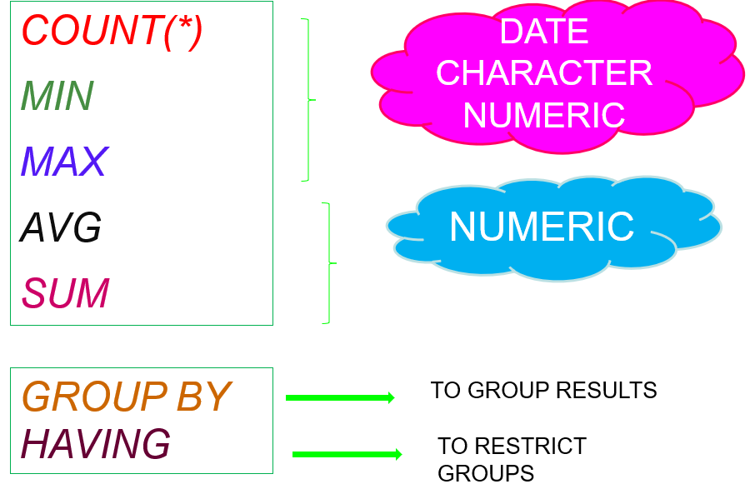

The GROUP BY clause is used to divide the rows in a table into smaller groups.

The GROUP BY clause is used with the SELECT clause.

SQL groups the result after it retrieves the rows from a table.

Conditional retrieval of rows from a grouped result is possible with the HAVING clause.

The syntax for GROUP BY clause is

***SELECT[DISTINCT] <column list> | <expr>***

***FROM <table>[,<table>] [WHERE condition]***

***GROUP BY <col | expr>***

***[HAVING <cond>]***

ORDER BY clause can be used to order the final result.

**ORDER OF EXECUTION**

· It chooses rows based on the where clause

· It groups those rows together based on the group by.

· It calculates the results of the group functions for each group.

· It chooses and eliminates groups based on the having clause

· It orders the groups based on the results of the group functions in the order by. The order must use either a group function or a column in the group by clause.